Portfolio Risk Engine
Measuring and validating the market risk of a multi-asset portfolio: VaR, CVaR, correlation stress testing and backtesting
Project report · October 2026 · Python (yfinance, pandas, NumPy, SciPy, matplotlib)

Participants:
- BILONG Victor Cédric
- NKWEMFO TCHAMI Lilian

1. Project overview
The Portfolio Risk Engine project is a Python tool that measures the market risk of a portfolio of financial assets from its historical data. It reproduces, at the scale of a personal project, the steps of a risk management process: estimating a potential loss by several methods, comparing them, testing the result against a rise in correlations, and then verifying after the fact that the model keeps its promises (backtesting). The notebook is organized into five blocks:
- Portfolio input and validation (interactive generator). The user enters at least six tickers; each is checked against Yahoo Finance (existence, absence of duplicates) and receives a strictly positive weight. The weights must sum to 1 and the portfolio must cover at least three asset classes.
- Data collection and preparation. Daily closing prices (yfinance library), simple returns, mean returns and correlation matrix.
- Risk measurement. VaR and CVaR by three methods: historical, parametric and Monte Carlo simulation.
- Correlation stress test. Assessment of what diversification is worth when correlations increase.
- Backtesting. Kupiec test over the whole period, then a backtest on a rolling 250-day window.

2. Illustrative portfolio
To illustrate the implementation, we selected six assets of different natures (stocks, index, gold, cryptocurrency) and assigned them arbitrary weights (Table 1). This is a pedagogical example and not an investment recommendation: the tool accepts any portfolio that meets the input constraints.
Table 1: Illustrative portfolio (daily data from January 3, 2017 to December 30, 2022)
Asset | Type (Yahoo Finance) | Weight | Mean daily return | Daily volatility
NVDA | Stock | 30% | 0.167% | 3.16%
^GSPC | Index (S&P 500) | 25% | 0.043% | 1.27%
AMZN | Stock | 20% | 0.076% | 2.13%
BTC-USD | Cryptocurrency | 10% | 0.301% | 4.81%
GLD | ETF (gold) | 10% | 0.032% | 0.87%
GC=F | Futures (gold) | 5% | 0.034% | 0.93%
Portfolio |  | 100% | 0.111% | 1.71%
Asset volatilities derived from the diagonal of the covariance matrix in the notebook; portfolio volatility derived from the parametric VaR.
The history covers 1,508 daily returns (dates common to all assets). It includes the March 2020 crash and the 2022 decline, but also strong bull phases in technology stocks and Bitcoin. The portfolio's mean return comes out at 0.111% per day and its volatility at 1.71% per day.
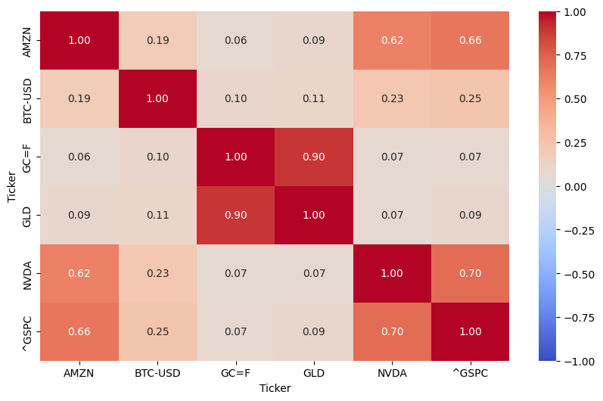
Figure 1: Correlation matrix of daily returns
The matrix (Figure 1) reveals three blocks. The equity assets, AMZN, NVDA and the ^GSPC index, are strongly correlated with each other (0.62 to 0.70). Gold (GC=F and GLD) is almost independent of equities (0.06 to 0.09), but these two lines are correlated at 0.90 because they replicate the same underlying asset. Bitcoin occupies a separate position: weakly correlated with the rest (0.10 to 0.25), it is also very volatile (4.81% per day versus 2.13% for AMZN). This structure explains much of the results that follow.

3. VaR and CVaR: methods, results and interpretation

3.1 Results
Table 2: 1-day VaR and CVaR, historical and parametric methods
Method | 95% VaR | 95% CVaR | 99% VaR | 99% CVaR
Historical | 2.66% | 4.07% | 4.86% | 6.56%
Parametric (normal distribution) | 2.71% | 3.42% | 3.88% | 4.46%
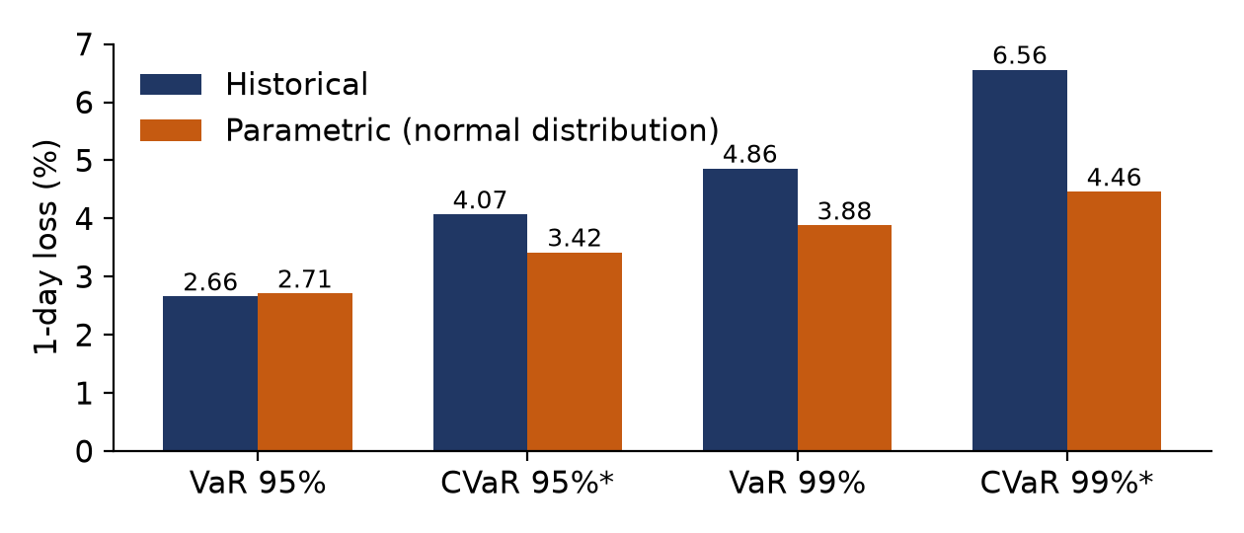
Figure 2: 1-day VaR and CVaR, historical and parametric
Table 3: 10-day Monte Carlo (10,000 paths)
Method | 95% VaR | 95% CVaR | 99% VaR | 99% CVaR
Monte Carlo (notebook) | 8.09% | 10.06% | 11.35% | 12.93%
Parametric extrapolated to 10 days | 7.80% | 10.06% | 11.49% | 13.33%

3.2 Interpretation
Agreement at 95%, divergence at 99%. The historical VaR (2.66%) and the parametric VaR (2.71%) differ by only 2%: at the heart of the distribution, the normal distribution is a good approximation. At 99%, the historical VaR (4.86%) exceeds the parametric one (3.88%) by 25%, because the real tails are fatter than those of a normal distribution.
The CVaR reveals what the VaR does not say. The CVaR/VaR ratio is 1.53 (95%) and 1.35 (99%) historically, against about 1.25 and 1.15 for a normal distribution. The historical CVaR thus exceeds the normal CVaR by 19% at 95% (4.07% versus 3.42%) and by 47% at 99% (6.56% versus 4.46%): the further one goes into the tail, the more the normality hypothesis understates the average loss.
The 10-day Monte Carlo is not directly comparable with the 1-day results. Higher losses (8.09% at 95%) are normal over a longer horizon. The CVaR/VaR ratios of the simulation (1.24 and 1.14) are those of a normal distribution: the Monte Carlo reproduces the assumptions of the parametric model without really correcting its limits. Its value lies elsewhere: a free horizon, and the flexibility to incorporate non-normal shocks or path-dependent products.

4. Backtesting

4.1 Kupiec test
The Kupiec test (proportion of failures) checks that the frequency of exceptions, that is, of days when the loss exceeds the VaR, is consistent with the stated confidence level. Under the null hypothesis, the daily probability of an exception is α = 1 - c (5% or 1%). For x exceptions observed over n days, the likelihood ratio statistic is:
LR = -2 (ℓ₀ - ℓ₁) , ℓ₀ = x ln α + (n - x) ln(1 - α) , ℓ₁ = x ln(x/n) + (n - x) ln(1 - x/n)
It follows a χ² distribution with 1 degree of freedom: the model is rejected at the 5% threshold if LR > 3.84. The test is two-sided: it penalizes a model that is too optimistic as much as one that is too conservative. It is applied here to the 1-day parametric VaR over the 1,508 returns.
Table 4: Kupiec test on the parametric VaR (5% threshold, critical value 3.84)
Level | Observed exceptions | Expected exceptions | Observed rate | LR | p-value | Decision
95% | 71 | 75.4 | 4.71% | 0.28 | 0.60 | Not rejected
99% | 26 | 15.1 | 1.72% | 6.57 | 0.010 | Rejected
Exception counts derived from the observed rates (n = 1,508); p-values computed from LR.
- At 95%: 71 exceptions against 75 expected (4.71% versus 5%), LR = 0.28, p = 0.60. The model is not rejected: the 95% VaR is correctly calibrated on the sample.
- At 99%: 26 exceptions against 15 expected (1.72% versus 1%), i.e. 72% more. LR = 6.57 > 3.84 (p ≈ 0.01): the model is rejected, which confirms the tail analysis of section 3: the normality hypothesis understates extreme losses.
- Scope of the test: the VaR is estimated on the same data as those used to test it, which favors the model; a rejection at 99% in this favorable setting is therefore a strong signal. Conversely, the test ignores the clustering of exceptions over time.

4.2 Backtest on a rolling 250-day window
To get closer to real-world use, the notebook re-estimates each day the mean and covariance over the previous 250 days (about one trading year), stopping at the previous day in order to avoid any look-ahead bias. The day's 95% parametric VaR is then compared with the actually observed return. Over the 1,258 days tested (January 2018 to December 2022), there are 89 exceptions (7.07%) for about 63 expected at 5%. Out of sample, the model therefore clearly understates risk.
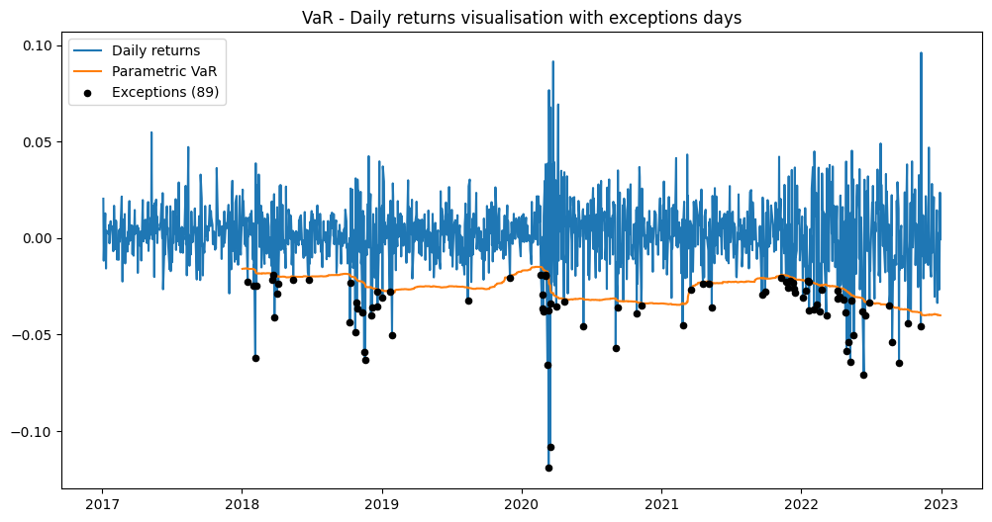
Figure 3: Daily returns, rolling 95% parametric VaR and exceptions
The exceptions cluster in early 2018, in the fourth quarter of 2018, in March 2020 and especially in 2022. In these episodes, volatility rises faster than the window can incorporate it: a VaR calibrated on a calm year is too low when the regime changes. Conversely, after the 2020 crash, the VaR remains high (around 3.3%) for nearly a year, until the crisis days leave the window, hence the low number of exceptions in 2019 and in the year following the shock. This slow reaction is typical of an equal-weight window; more responsive estimators (EWMA, GARCH models) are its natural extension.

5. Correlation stress test
The stress test keeps the individual volatilities and changes only the correlations. The stressed matrix is a blend of the observed matrix ρ and a matrix J of perfect correlations: ρ(λ) = (1 - λ) ρ + λ J, with λ from 0 (observed correlations) to 1 (all correlations equal to 1, hence no diversification). A blend of two valid correlation matrices remains a valid matrix. At λ = 1, the portfolio volatility reaches its upper bound Σ w_{i}σ_{i}. The parametric VaR/CVaR and Monte Carlo VaR/CVaR at 1 day (95%) are recalculated for each λ.
Table 5: 1-day VaR and CVaR (95%) according to the stress coefficient λ
λ | Parametric VaR | Monte Carlo VaR | Monte Carlo CVaR | Parametric CVaR
0 | 2.71% | 2.71% | 3.37% | 3,42%
0.25 | 2.98% | 2.94% | 3.70% | 3.76%
0.50 | 3.23% | 3.21% | 4.01% | 4.08%
0.75 | 3.46% | 3.45% | 4.30% | 4.37%
1 | 3.68% | 3.68% | 4.56% | 4.64%
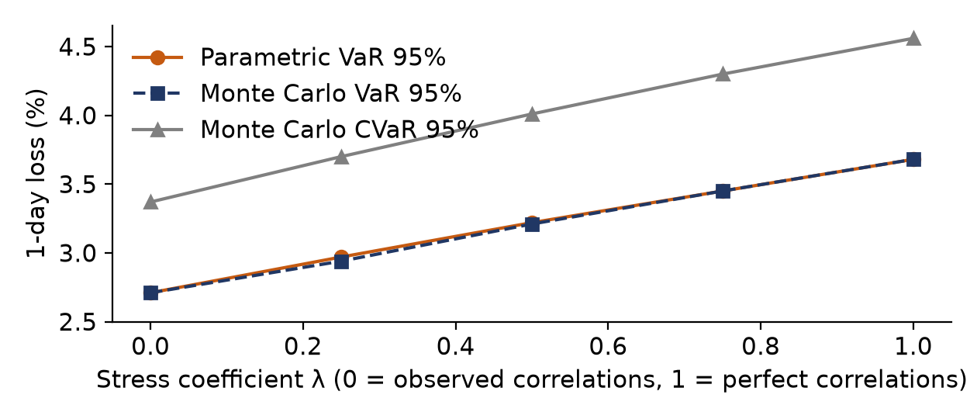
Figure 4: 1-day VaR and CVaR (95%) as a function of the stress coefficient

Conclusion:
- A potential increase in losses. The VaR goes from 2.71% to 3.68% and the CVaR from 3.37% to 4.56%, as the portfolio volatility goes from 1.71% to 2.31%. Diversification therefore provides a reduction in risk in the observed configuration.
- Consistent methods. The parametric VaR and Monte Carlo coincide to within 0.04 point; the differences are sampling noise. The CVaR/VaR ratio remains close to 1.24: the stress changes the scale of risk, not the shape of the distribution.

6. Assumptions and limitations
- Data and portfolio. Simple returns computed from Yahoo Finance adjusted prices on common dates (Bitcoin weekends are discarded; its price is not synchronized with US market closes, which may understate correlations). The 2017-2022 period includes the 2020 crash and a sharp rise in technology stocks: the results are specific to these regimes.
- Modeling assumptions. Returns are normal, independent and identically distributed for the parametric and Monte Carlo methods (no fat tails, skewness or volatility clustering); a covariance matrix that is constant over the period; constant weights with daily rebalancing; the historical mean return is included in the VaR.
- Role of the mean. The parametric VaR incorporates the historical mean return, which reduces it by 0.11 point. This choice assumes that the past period, very favorable to risky assets, will repeat itself; many practitioners set a zero mean at 1 day.
- Limits of the methods. Historical: depends on the sample and poorly describes the 99% tail. Parametric: understates extreme losses. Monte Carlo: 10,000 paths and a fixed seed leave sampling error on the 95% VaR (increasing the number of draws would reduce it); the portfolio is simulated as a weighted sum of logarithmic returns, which is an approximation. Stress test: λ = 1 is a theoretical bound and not a calibrated scenario; volatilities are not stressed.
- Limits of the tests. The Kupiec test is performed on the estimation sample, without a test of the independence of exceptions (Christoffersen); limited power at 99%. The rolling backtest is assessed by comparing counts, without a formal test, with an equal-weight window that reacts slowly to regime changes.

7. Conclusion and extensions
The Portfolio Risk Engine shows that a VaR based on the normal distribution is reliable at 95% in a stable regime, but that it understates risk at 99% and during volatility regime changes, as confirmed by the Kupiec test (rejection at 99%), the comparison of CVaRs and the rolling backtest (7.07% of exceptions). The CVaR provides the information on the severity of losses that the VaR does not give. The stress test quantifies the value of diversification, roughly and shows that it rests mainly on Bitcoin and gold.
The possible extensions are a more responsive EWMA volatility, GARCH models, fat-tailed distributions (Student) or filtered historical simulation, the Christoffersen independence test, as well as increasing the number of Monte Carlo simulations.

